

Impact of COVID-19 on Daily life

[An Analytical Study in Behavior, Concerns, and Adjustment]



June 8, 2025

Ananya Jha

Impact of COVID-19 on Daily Life: An Analytical Study on Behavior, Concerns, and Adjustments

Overview

This project presents a structured analytical study to understand how different age groups adapted to the challenges faced during the COVID-19 pandemic, the behavioral and emotional shifts that occurred, and the lasting changes in lifestyle and decision-making.

This data-driven approach aims to uncover insightful trends and actionable lessons to enhance future crisis preparedness.

The main goal of the project is also to understand how COVID-19 affected people’s daily lifestyle, mental health, financial behavior, education/work patterns, and health precautions. What were the major behavioral and emotional shifts experienced by individuals across different age groups, and what lessons can be drawn from them for future crises?

Project Objective

To analyze the impact of COVID-19 on lifestyle and behavioral domains, including:

1. Daily routines and lifestyle adjustments
2. Mental health and emotional responses
3. Financial behavior and decision-making
4. Education and work transformation
5. Health, hygiene, and precautionary habits

Target Demographic Segments (User Profiles)

1. Pre-teens (5 – 12 years)

Focus: Impact on learning, play routines, screen-time habits, and emotional development.

1. Teenagers (13 – 19 years)

Focus: Academic disruptions, digital adaptation, social disconnection, identify formation challenges.

1. Young Adults (20 – 35 years)

Focus: Career uncertainties, remote work transition, financial stress, mental health strain, dating/social life shifts.

1. Middle-Aged Adults (36 – 60 years)

Focus: Job stability, family care roles, financial planning, work-life balance, health awareness.

1. Elderly (60+ years)

Focus: Isolation, health risk awareness, digital divide, reliance on support systems, fear/anxiety levels.

Stakeholders Involved

1. Individuals (age groups ranging from pre-teens to elderly)
2. Healthcare administrations – to understand behavior and mental health trends
3. Government and policy-makers – to plan better public communication and emergency response
4. Educational institutions – to learn how students coped with learning shifts
5. Mental health professionals – to assess patterns of psychological stress

Google Form Survey

<https://docs.google.com/forms/d/e/1FAIpQLSd5-yMh7BjTy0WC4CKAhpKNIf4E-xK8KK0kgIuUikS8NHUGXA/viewform>

Data Insights

1. **How did mental health ratings change from before to during COVID-19 across age groups?**
   * Which age group experienced the biggest drop in mental health?

* As per the data analysis, every age group except for the teens had a drop in their mental health during COVID-19. The elderly experienced the biggest drop in the mental health rating, with scores falling from 3.29 to 2.51 (a 0.78-point drop), indicating they were the most affected group.

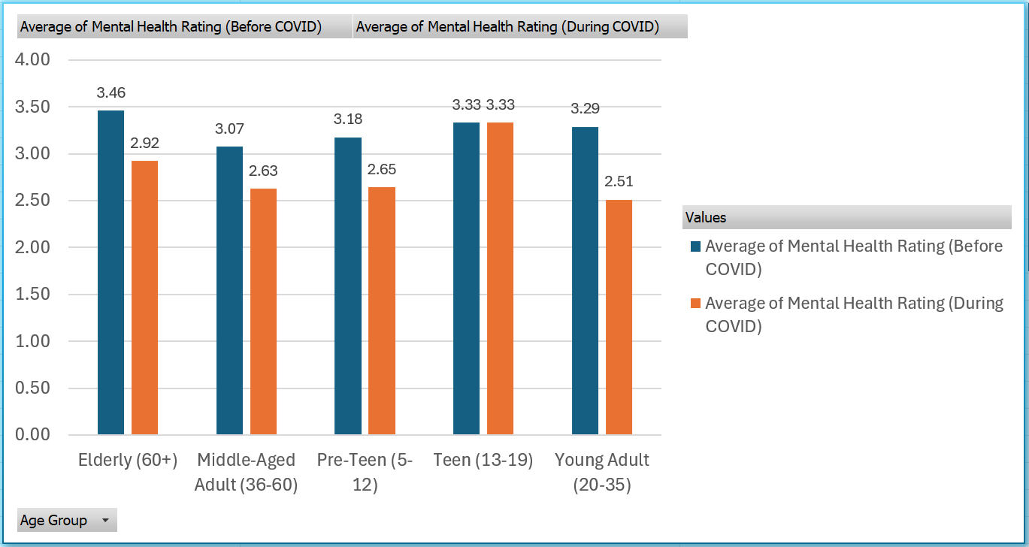

1. **Is there a correlation between screen time increase and mental health decline?**
   * Does more screen time = worse mental health?

* Contrary to popular belief, more screen time was linked to slightly better mental health. Individuals with 6-8 hours of screen time had the highest average rating (2.73), while those with less than 2 hours had a lower rating of 2.64. the lowest rating (2.52) was seen in the 2–4-hour group, suggesting a non-linear correlation.

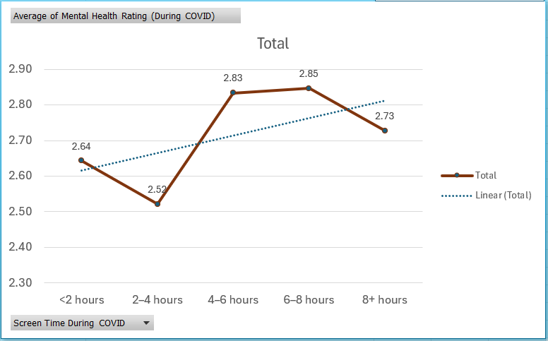

1. **Which groups (gender) were most affected financially (e.g., job loss or reduced income)?**

* Non-binary individuals and those who preferred not to disclose their gender were the most financially affected, with 10 and 12 job losses respectively. In contrast, males and females experienced the fewest job losses (4 each), and males had the lowest count of slight income reduction (only 6 cases) whereas all other groups had the same number of cases each (9).

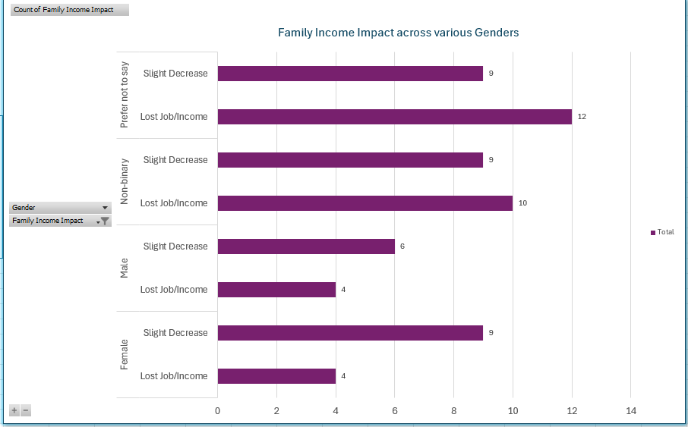

1. **How did mask-following behavior vary by age group or gender?**

* Were younger people less compliant?
* Young adults were contrarily the most compliant with the mask guidelines – 18 always and 14 mostly followed them. Only 1 young adult reported never using a mask. Middle-aged adults also showed strong compliance.

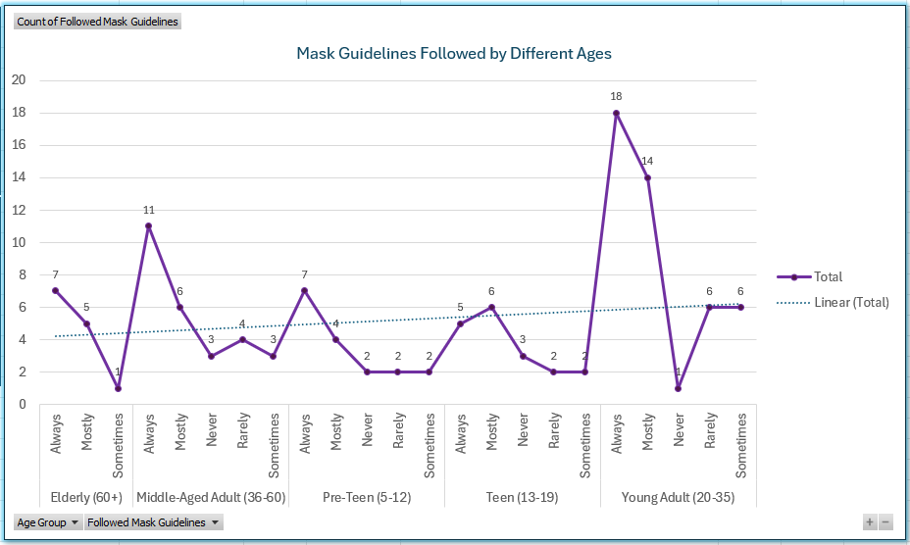

1. **Which age group saw the biggest increase in screen time during the pandemic?**

* Young adults saw the biggest increase in screen time during the pandemic, with 15 individuals reporting over 8 hours daily. Along that, 7 middle-aged adults and teens, and 6 young-adults were having screen times of 6-8 hours, indicating high digital engagement.

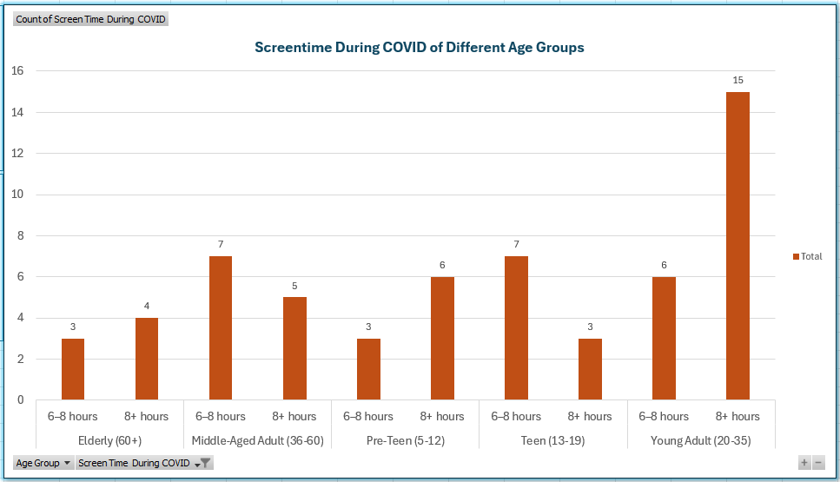

1. **Was "Work/Study from Home" more common among young adults or middle-aged groups?**

* Work/study form home was more common among young adults, with 17 always and 16 occasionally doing so. In contrast, only 12 middle-aged adults regularly worked/studied from home, and 7 did so occasionally, showing clear dominance by the younger group.

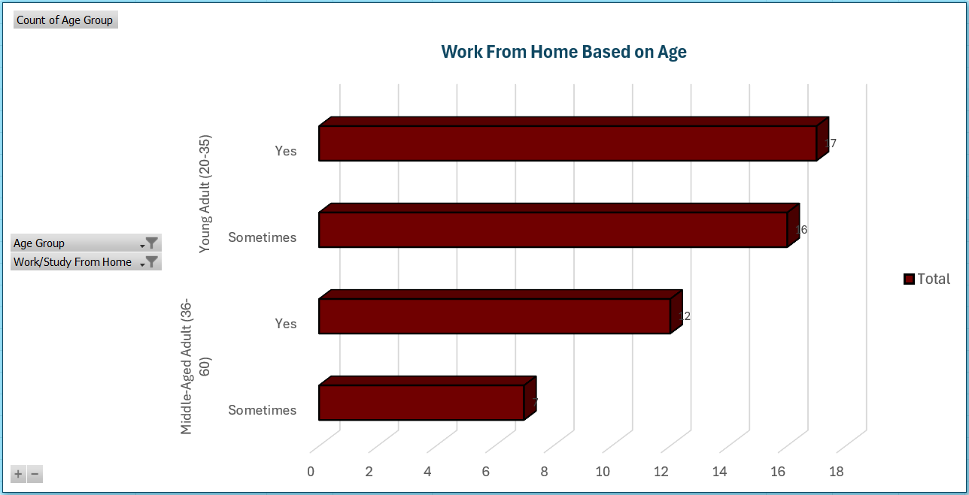

1. **How often did respondents check COVID-related news?**

* Any link between news frequency and mental health?
* Individuals that checked the COVID-related news once a day had the highest mental health rating (3.35). The lowest rating (2.28) was seen in those checking the news only a few times a week. Interestingly, those who checked the news multiple times a day had better mental health rating (2.83) than those who and never (2.41) or rarely (2.60) checked, suggesting that moderate, consistent news intake was linked to better mental well-being.

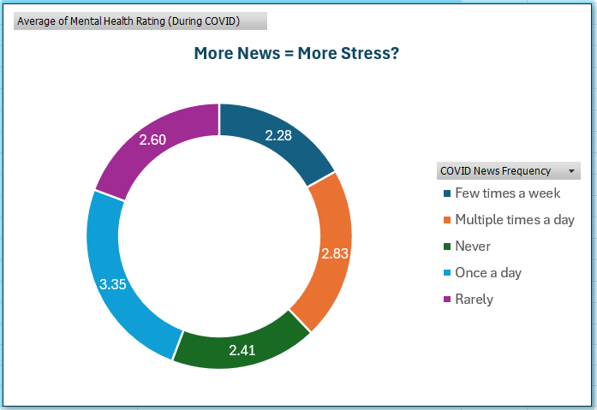

1. **What were the most common major challenges faced?**

* Can you group them by gender?
* The fear of job loss was the most common challenge across all gender groups, with 8 males and 8 females reporting it. Among those who preferred not to disclose their gender, top challenges included fear of infection, online learning difficulties, and limited healthcare access. Additionally, isolation emerged as a key issue among male respondents.

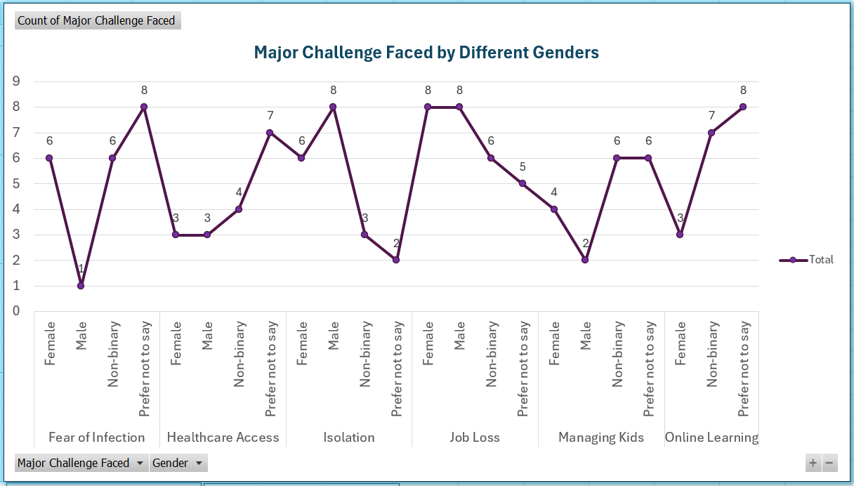

Root Cause Analysis

* Mental Health Decline Among the Elderly

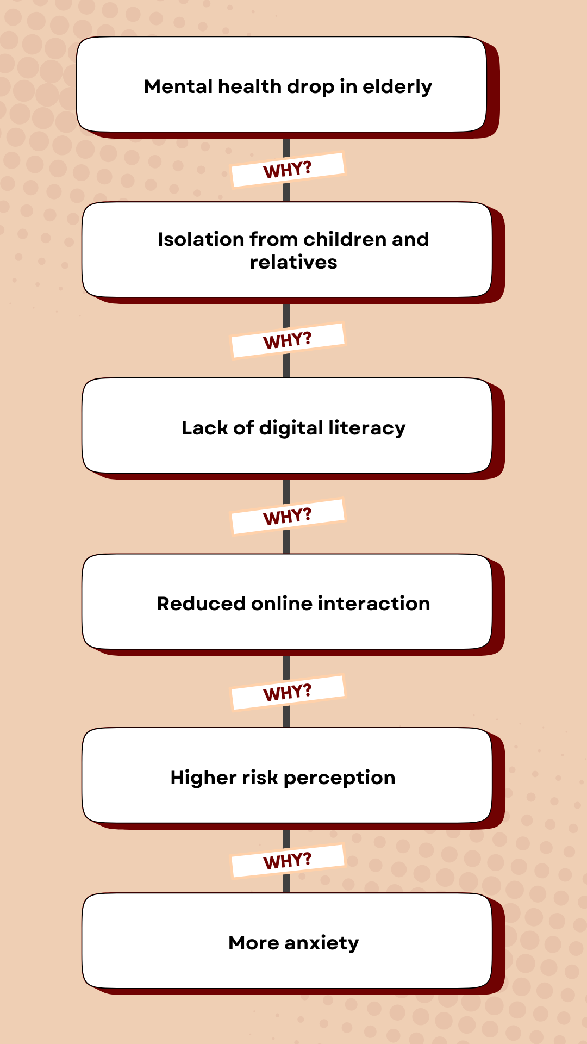

* Non-Binary Individuals Were Mostly Financially Affected

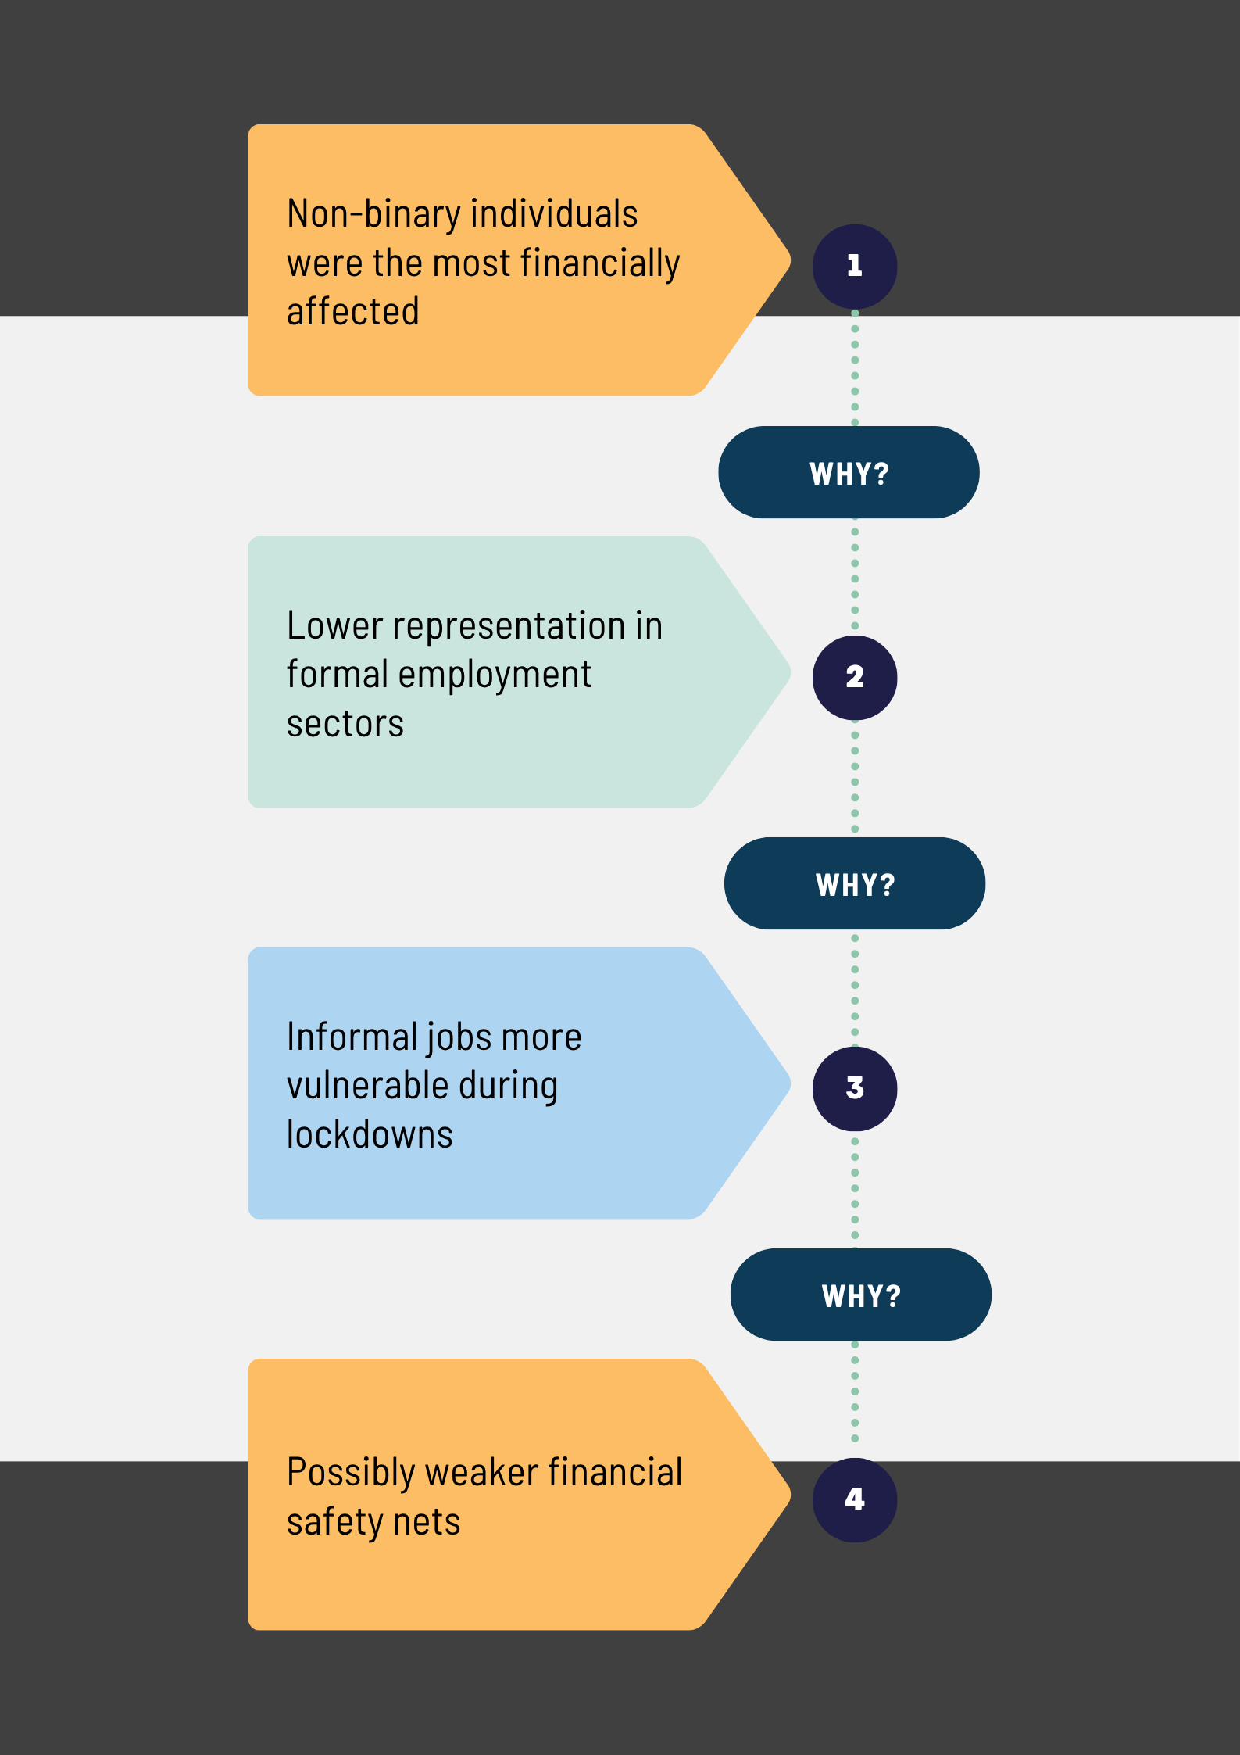

* Young Adults Showed the Highest Screen Time Spike

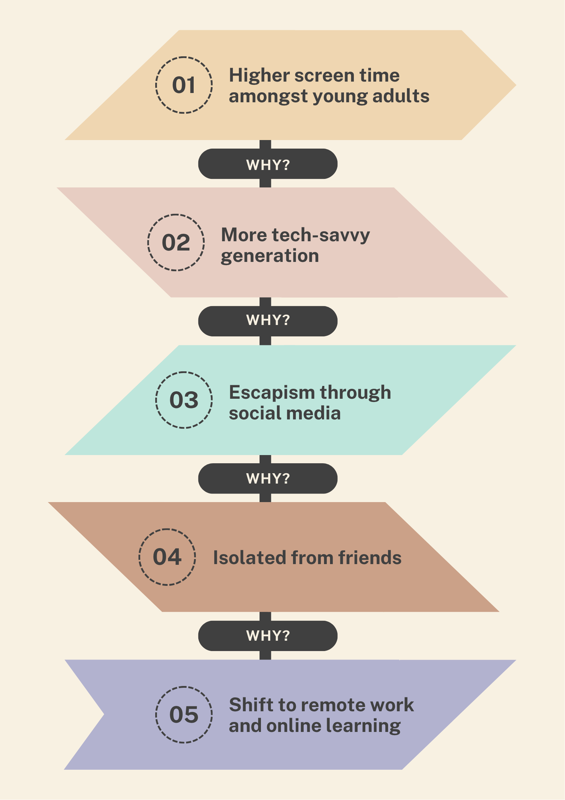

* High News Exposure = Better Mental Health?

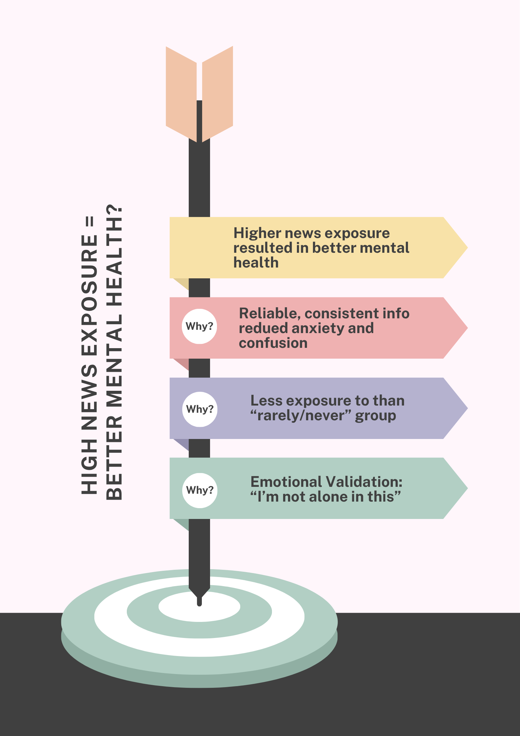

* Mask Compliance Highest in Young Adults

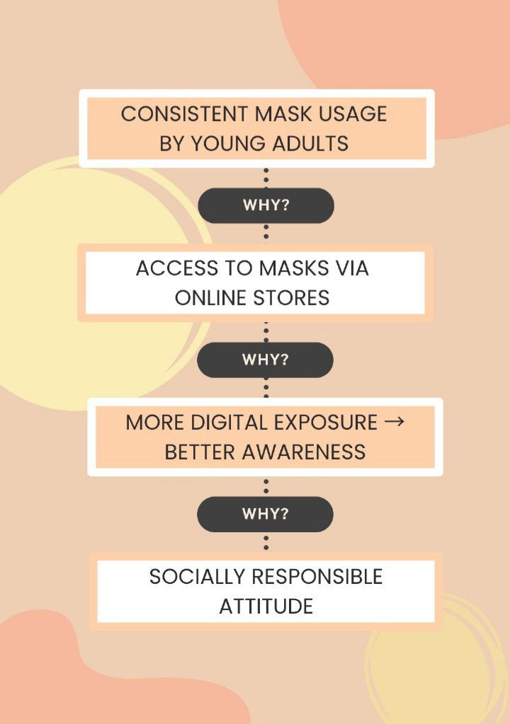

Root Cause Summary Table

|  |  |  |  |
| --- | --- | --- | --- |
| Insight | Root Cause Category | Impacted Group | BA Recommendation |
| Elderly mental health drop | Isolation, digital gap | Elderly | Create non-digital outreach methods |
| Financial impact (non-binary) | Job instability | Non-binary | Inclusive economic programs |
| High screen time amongst young adults | Tech savvy generation, escapism, online work/study | Young adults | Develop digital wellness platform |
| More news = better mental health | Reliability, emotional validation | All | Consistent news delivery |
| Mask compliance high in young adults | Online stores, social responsibility | Young adults | Promote social awareness |

Conclusion

This project showed that different age groups were impacted in distinct ways, with the elderly facing the greatest mental health burden, young adults adapting digitally and becoming more socially responsible but struggling emotionally, and non-binary individuals disproportionately affected financially. It also showcases that if reliable news is provided consistently, then it can boost mental health. These insights point to the improvement of inclusive crisis planning, targeted mental health support, and balanced information delivery in future pandemics.

Reflection

Working on the COVID-19 lifestyle impact project felt like the perfect second step in my Business Analyst Journey. It helped me understand the role better and also boosted my confidence in solving real-world issues. It also made me further familiar with the different tools I’ll be using in the future.

This was a large project, so I broke it down into manageable steps. First, I crafted the objective and designed a detailed Google Forms survey. The responses were generated using ChatGPT to simulate data. I then used Microsoft Excel for cleaning, organizing, and analyzing the data, applying pivot tables, slicers, and basic charts to extract and visualize insights.

The third step was to get the data insights by asking the right analytical questions, and analyzing the data to get the answers to them. The answers were data-backed and I also added the visualization for a better presentation of the project. The fourth step was performing Root Cause Analysis on five major insights, with visuals created on Canva.

Finally, I added a root cause analysis summary table, conclusion, and this reflection to wrap up the project.

I’ve truly enjoyed every part of this process. It boosted my confidence, helped me build new skills, and gave me a clearer view of what Business Analysts really do. While the project took time, I can say with full honesty that it was worth every second. I’m still learning, but I’m committed to practicing more, improving continuously, and becoming the best version of a Business Analyst I can be.